Brake Adapter Instructions

Front Hardware List:
4 - Bolts - M12x1.50x45mm or 50mm long - 10.9 hardness
4 - Spacers - 25mm wide x 20mm long spacers, stainless or coated steel
4 - Studs - M12x1.25mmx45mm, 10.9 hardness
4 - M12x1.25 Nuts- 10.9 hardness
8 - Washers, hardened
2 - ½” Plate Adapter Brackets
Front Instructions:

- Carefully support the front of the vehicle on jack stands. Make sure you have the parking brake set before you lift the car.
- Remove the wheel, pads, caliper, rotor, and OEM caliper bracket.
- Start by drilling the mounting ear holes in the stock spindle to ½”. CAUTION: Make sure to drill the holes perfectly straight.
- Insert a wheel stud in each hole. They should push in through roughly half of the shouldered area and will pull the rest of the way in when you tighten them. Do not worry about it.
- Next you need to grind the top mounting ear on the spindle. You will need to remove the casting ridge on top of the upper mounting ear. Make this area fit the spacer as shown in the second picture. One of the spacers will rest here. If necessary you may flatten the side of the spacer to increase clearance. Also grind off the casting ridge in the corner between the between the top mounting ear and the base of the spindle. (see picture #1) 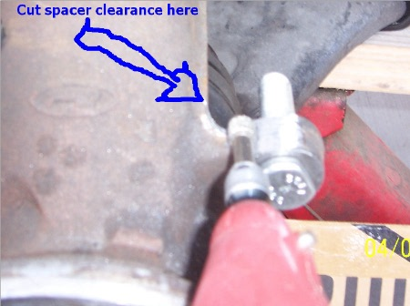
- Test fit the adapter bracket on the studs. Use the spacer in position where you ground the spot on the spindle to check if you removed enough material. Use a nut to keep the adapter bracket flush if needed. CAUTION: The spacer hole should line up with the hole in the bracket. You should not see any ridge from the separation of the two pieces. If it does not line up then remove spindle material until it lines up properly. This is extremely important. 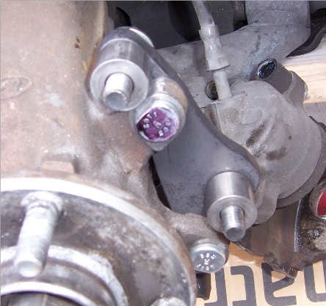
- Mount the adapter bracket on the studs in the correct orientation. NOTE: The top hole should point diagonally up and to the left on the passenger’s side, & diagonally up and to the right on the driver’s side.
- Install a washer and a nut on each stud and then tighten them. Make sure you pull the studs flush on the backside of the spindle mounting ear.
- Mount the rotor on the hub. Use a nut to hold the rotor flush with the hub. This will ensure you are checking the proper final clearances around the OEM caliper bracket.

- Put washers on two of the provided bolts. Grab 1 of each respective spacer: regular & flat-spotted. Have the OEM caliper bracket close. Place the spacer in position. Start a bolt with washer on it in the top adapter bracket hole and push it though the spacer. Grab the OEM bracket and start to thread the top bolt. Install the lower bolt with washer, the second spacer, and start threading the bolt into OEM bracket. Hand-tighten the bolts and check clearance around the rotor. It should be fine. NOTE: Make sure the rotor is mounted FLUSH when checking clearance. This is why using a nut to hold the rotor flush is very critical. 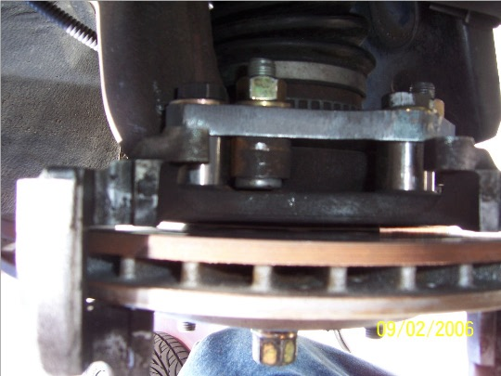
- If the clearance is fine then tighten the 2 bolts in the OEM caliper bracket. If not then your OEM caliper bracket will need the casting flash to be removed from the inside of it. Work it until you have adequate clearance on all sides.
- Re-install the pads & caliper. CAUTION: Make sure the base of the caliper is not hung up on the adapter bracket. Some calipers have excessive casting flash on the bottom of them.
- I strongly advise using new pads. SS brake lines are a good idea for both durability and the added stress placed on them from the caliper being at a new angle on the larger rotors.
- Repeat on other side.
- Bleed brakes with high quality fluid only.
- Install both wheels properly and lower the vehicle.

Spacer Clearance – Alternate method when you machine a flat spot in the spacer.
