Rear Hardware List:
2 - Flange Head Bolts, shouldered - M10x1.5x40mm - 10.9 hardness
-OR-
2 - Socket Head Bolts - M10x1.5x40mm - 10.9 hardness
2 - Washers, hardened
-AND-
4 - SS Spacers - 24mm wide x 10mm long with 7/16" holes
2 - 3/8” Plate Adapter Brackets

Rear Instructions:

- 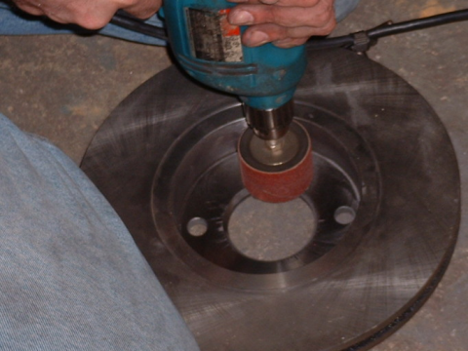You may prepare your former Front SVT Contour rotors for mounting on the rear by beginning the work described in section 3 prior to putting the car up.
- Carefully support the rear of the vehicle on jack stands and remove both rear wheels. Leave the car in gear or block the front wheels.
- Use a power drill and a drum sander to mill the inside of the rotor hat to remove all casting flash and increase the inside diameter. You will find that the hat gets more narrow where it bottoms out with the inside mounting face. Use a grinding stone either in the drill, or preferably with a die grinder to increase the inside diameter near where it meets the mounting face as necessary. You will know when you have done enough widening when the rotors fit the rear hubs loosely. If they go on and stay put when you remove your hands, they are too tight and you must continue. This is IMPORTANT! The rotors must sag loosely when you remove your hands.
- At this time painting the rotor hats and inside and outside edges may be a good idea if they are not already coated. Remember that the rear pads are not thick enough to cover the whole face of the rotor and you may want to use VHT or Thermotec paint to spray the inner half of the rotor face both front and rear. Place the old pad on the rotor near the outer edge to determine contact area thickness and mask-off the area or spray and remove paint from the contact area with a rag and brake parts cleaner. Let the rotor dry.
- 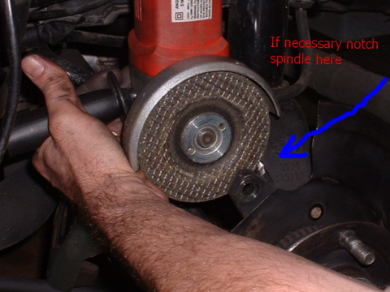Remove the rear calipers and brake brackets. (T50 Torx bit for the stock bracket bolts. Save these bolts!)
- Again test fit your pre-prepared rotors; continue to work them until they fit easily. Paint as necessary.
- Install the adapter brackets using the OEM Torx head bolts into the threaded holes of the brackets and make them snug. Examine the fit. You will need to grind a small notch in the spindle right where the bracket is closest to it after mounting. There is a notch in the bracket to accommodate the spindle part way, you must grind a little bit on the spindle to ensure clearance of the bracket at this point. Paint the notched area to prevent corrosion.
- Prior to installing the bracket permanently, insert the M10x1.5x40mm flange-head bolt into the uppermost bolt hole. There will not be clearance around the spindle to insert this bolt after the bracket is bolted down.
- Tighten the Torx bolts holding the adapter bracket securely to factory torque specs or approximately 35 ft-lbs.
- Prepare the stock rear caliper brackets: This is the most difficult and time consuming part. Do a good job.
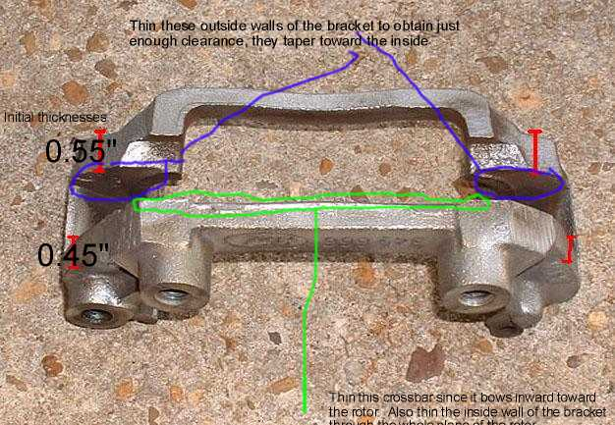
Note: The rear brackets will need to have the inside widened to clear the thicker front rotor. Careful measurement of rotor thickness will tell you how much you need to widen them. If the rotors are brand new, have them turned to pull off 0.015” per side to make this job easier! Do not worry about these rotors being too thin as they are significantly thicker and heavier than the stock rear rotors even at minimum thickness. The added metal will still increase fade resistance.

- The stock rear brackets have a significant amount of casting flash on the inside and outside surfaces. Remove as much as you want on the exterior for cosmetics without reducing the design thickness of the bracket. This will be obvious due to thin lines from the moulds. On the inside it will be critical to grind as much away using a dremel and/or die grinder for clearance. Test fit often by slipping the bracket over the rotor.
- The bracket mounting holes are connected with a crossbar (see photo) this crossbar is bow-shaped and the middle of the bow sticks out towards the rear rotor face. This bowed area thickness must be reduced to flush with the backside of the bolt mounting holes for maximum rotor clearance.
- 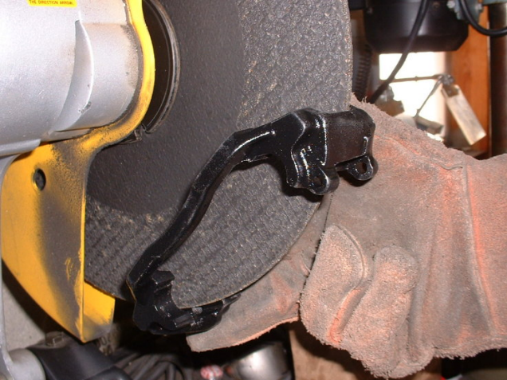WARNING: Do not use the following method without experience and hand/eye protection! The easiest and quickest way I’ve found is to use a chop saw that is rigged to run with the blade cover open. Using gloves, carefully put the bracket over the chop saw as it would go over the rotor, keeping gloved hands to the outsides while holding the bracket. Press the bracket against the flat side of the cutting wheel on both inside faces to gently thin away material. Move the bracket deeper onto the cutting disk to get the casting flash at the outer extremes. Be sure to use the disk to flatten the bowed portion of the cross bar.
- After ensuring the brackets fit cleanly over the rotors, clean and paint the brackets with VHT or Thermotec paint to protect the exposed metal where you ground the casting flash from corrosion. This is a good time to color coordinate your paint scheme. ( I chose black VHT for brackets and Silver Thermotec for the calipers)
- Install the rotor loosely.
- Install the provided M10x1.5mm bolts into the holes so they stick through a little bit. Note: you will be provided with either flange head bolts OR regular bolts with washers. If the latter, use one washer per bolt head on the opposite side of the bracket from the rotors. Place the spacers over the bolts on the rotor side of the bracket.
- Hold the bracket over the rotor in the rough position of the bolt holes. Begin threading in the top bolt into the bracket. Follow by threading the bottom a few turns. You will now have to thread a few turns at a time, alternating from top to bottom on the bolts AND positioning the rotor on the hub at the same time. Due to the size of the rotor the rotor must not be all the way on the hub when the bracket is first installed, and will be moved inward with the bracket as the bolts are tightened until it is loosely in place on the hub.
- Use two lug nuts and secure the rotor to the hub. Spin and check for clearance and lateral runout. Excessive runout will indicate either a warped rotor or that the inside of the rotor hat was not widened sufficiently and the rotor is hanging up on the edge of the wheel hub. Remove and correct the problem until minimal runout is apparent and there is sufficient clearance on either side of the rotor with the bracket.
- 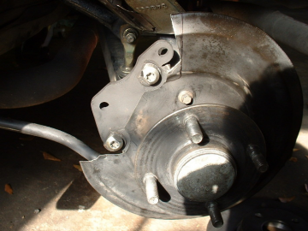 Install the pads. The pads will be mounted close to the outer edge of the rotor. If the pads are too far out or too far in, there is sufficient “play” designed into the bolt holes/spacers to allow small adjustments in or out on the bottom, top, or both bolt holes for both the OEM and adapter brackets. Adjust now until pad positioning is satisfactory.
- Test fit the caliper on the bracket assembly. You will see a portion of the rear metal dust/rock shield that is in the way of the upper end of the caliper. Mark a line on the metal shield that will allow you to cut and remove just enough of the shield to allow caliper clearance. A die grinder, dremel cutoff wheel, or hacksaw blade will suffice. You should be able to cut it without removing the rotor if using a rotary cutting tool, other wise, start unbolting. This should be the last time.
- Be sure to remove the plastic tie strap for the park brake cables on both sides of the car from the trailing arms before mounting the calipers. You can slide the zip tie further up the trailing arm to an area where the brake cable is close to the arm again and reattach it there. CAUTION: Failure to remove this plastic strap and/or reposition it may result in the cable being at a very poor angle when the caliper is mounted and may cause the cable sheath to pop loose from the cable mount on the caliper. The good news is that the cable is now higher than before and does not ride as close to the street. You do not need to ‘lock’ the cable sheath into the support bracket on the caliper; it only needs to be inserted in the hole. If it sits at a slight angle this will relieve pressure.
- 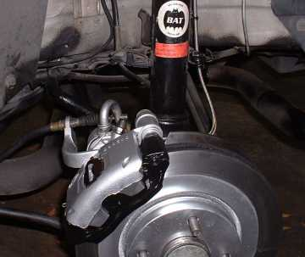 Bleeding brakes: You should bleed the right rear caliper before you mount it back on the car if you need to bleed the brakes due to the positioning of the bleeder screw. This is not a problem on the left side. Stick a piece of wood in to hold the piston from moving and have an assistant work the pedal while you bleed the caliper with the screw sticking straight up.

The finished product.

